August Rosenbaum - Vista
Formats: vinyl & digital
Release date: Nov 24, 2017
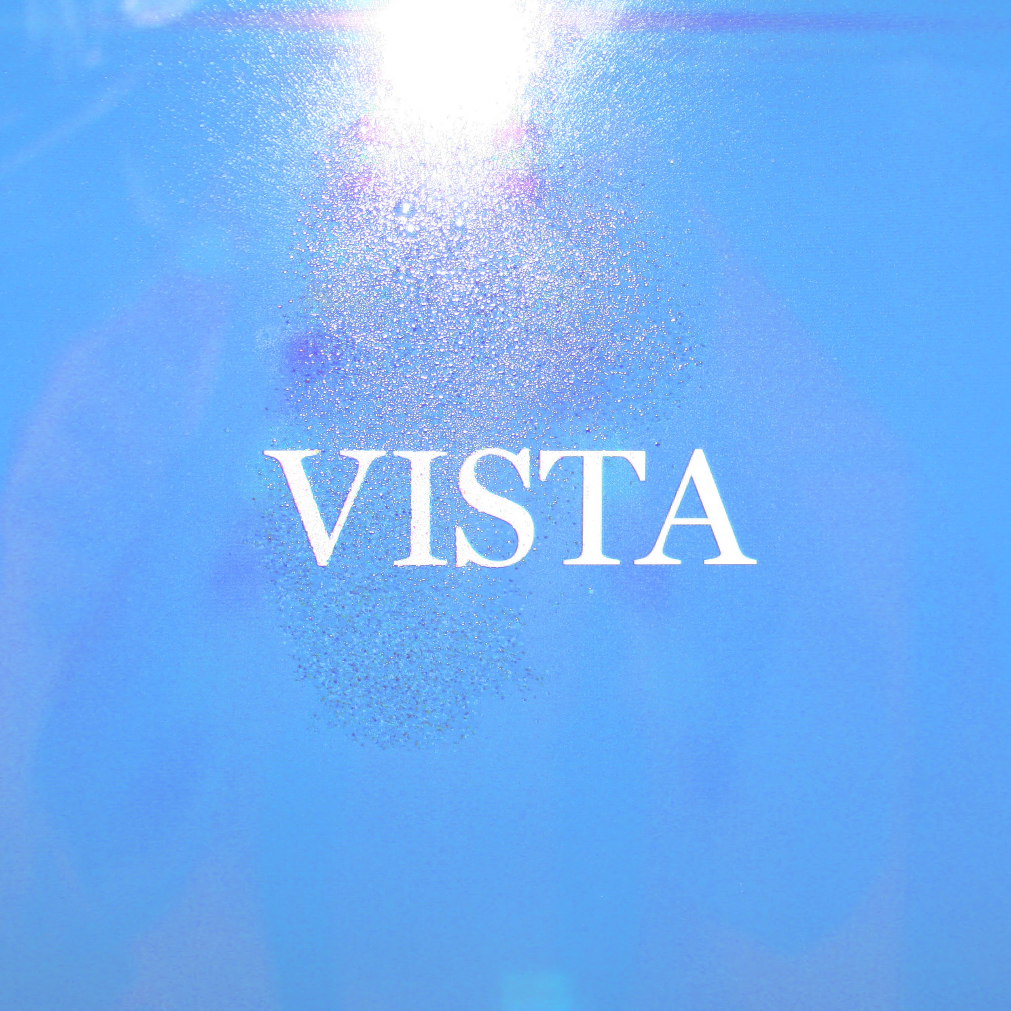
With Vista pianist and composer August Rosenbaum has created a fascinating album of evocative and soulful music that brings together his rich musical background in both jazz, classical music, film scoring and pop. Vista is written and produced in collaboration with Grammy-nominated producer Robin Hannibal who’ve worked with an impressive range of artists including Little Dragon and Kendrick Lamar.
While the name August Rosenbaum may not seem familiar, the Danish piano prodigy has been involved in some of the most influential Danish music in recent years. He has been touring the world as the keyboard player for Quadron, making string arrangements for Mø and recorded the piano on Rhye’s iconic album Woman. 2017 will be the year when August will put himself in front and center and release his new solo project signed to Tambourhinoceros (Efterklang, IRAH, Frisk Frugt etc.).

Tracklist
- Angelo
- Belmondo
- Nomad
- Nebula
- Killer
- Calling Out Feat. Philip Owusu
- Skin
- Tristana
- Emo
- Credo
- Wu
- Melville
- Victim

Credits
Produced by Robin Hannibal
Arrangements by August Rosenbaum and Robin Hannibal
Mixed by C.T. and R.H. at Rumours, NYC
Mastering by Dave Kutch at Mastering Palace (NYC)
Recorded between 2011-2016 at The Ship Studio (LA) by Aaron Espinoza, Rummet (Copenhagen, LA) by Robin Hannibal, Red Bull Studios (NYC) by Caleb Laven, and The Village (Copenhagen) by Bjørn Gjessing
Edited by Robin Hannibal and Robert Castillo

Track by Track
By August Rosenbaum

Angelo
Album opener Angelo evokes Italian soundtracks in name and nature, setting the tone of moody modernism explored in musical structure and instrumental touch, twisting, circling, and reeling the ear in around every corner.
Angelo, to me, is the key that opens the door to the album universe. It instinctively sets the mood: I press play, close my eyes and images of driving on a dark road unfold, surrounded by red wood pines, and a tingling sensation of something unknown about to happen.
There’s also a lot of Los Angeles in it. We drove around a lot at night while mixing the album, I guess it’s a bit cliché but there’s something about this music and transport, it’s hypnotizing. With Angelo I have this image of a ghost driver speeding on the wrong side of the road, lit by the headlights of the cars that pass by, all determined and anxious. The title is, of course, a nod to one of the absolute greatest film composers in my mind, Angelo Badalamenti. We had the local boys choir in Robin’s old neighbourhood sing the outtro vocal part.

Belmondo
Belmondo opens with a gentle break beat and string swings painting longing vistas in this miniature symphonic piece featuring Brandee Younger on harp.
We wanted Belmondo to have an Italo Amalfi-coast kind of melancholic grandeur, with the same intricate details and orchestral palet as in an old Morricone soundtrack, but also a clear 2017 feel. I hear bleached colors, blue horizon and a mafia aesthetic, crisp white shirts and buttoned up sleeves with a few dried blood stains on them that won’t wash off. The strings cut like knives on the theme. The mixing engineer Chris Tabron read something into the end part, he said “it’s like the strings are asking “what’s going to happen, how will we get by?” - and the woodwinds sweep in saying “we’ll be alright, don’t worry”.

Nomad
could be what it would sound like if a young Milton Nascimento would start out making music today. A brash grace combined with a stately advance, the persuasive drive of the ensemble replicated in beeps and bleeps that might more easily suggest the deserts and urban centres of distant planets where future generations revisit the past to reminisce on dreams of the future already unfolded.
Nomad builds on a percussive synth pattern that repeats and spins the theme forward. There’s a wandering feel to it, like making your way through the desert. Like with a lot of the songs on the album, we put hours and hours into finding the exact phrasing and timing in the synth theme, to make it feel like the synthesizer is singing in some future language we can only understand by the melancholia it evokes.

Nebula
Nebula is a theme for the future. To me it’s a dream of floating in infinite darkness - somewhere between a space odyssey and a fever dream, both heavy and weightless. When I close my eyes I see images from Stanley Kubrick’s A Space Odyssey and Tarkovsky’s Solaris. Both of which are among my all-time favourite soundtracks, btw.
We made this as one of the last songs on the record with Robin playing guitar and me playing the synths and melodies. I remember the singer Kimbra walked into the studio at one point while we were recording and just stood there for 10 minutes listening as if she had landed on another planet.
We wanted the lead melody to have a “talking”, emotional feel, like a computer telling a sad memory. I played it five times on top of each other to give it that hesitant feeling. Dorit Chrysler played the theremin, adding some extra stardust on the end part.

Killer
I have a big ‘Laura Palmer in the woods’ moment every time I listen back to Killer. I love having little visual fragments like this to lay the mood for writing and arranging a piece of music. The beat and sidechain feels like treading a determined pace, then reaching a clearing in the woods, and then there’s a body. That’s when the theremin comes, cool, threatening and beautiful - creating a brief suspenseful plateau, before the beat drops and treads on like a juggernaut.

Calling Out
Calling Out features the unique talent of my favourite singer in Denmark, possibly in the whole world, Philip Owusu. I remember reading an interview with Pharell Williams back when N.E.R.D. had their heyday. He quoted that one of the things he was listening to the most to at that time was this Danish soul duo, Owusu/Hannibal. I was 19. That was when I discovered Philip and Robin’s album, and it sounded so fresh. Still does actually.
For some reason Philip Owusu is a hidden gem on the Danish scene today; which is why I was so honoured that he would collaborate with me on the song Calling Out. When I called him, we had already finished the instrumental, but it felt like something was missing. We had this idea together of a swarm of male voices doubling the harmonies, like on Stevie Wonder’s “They Won’t Go When I Go”. Then Philip came up with these amazing top and counterpoint lines that made the whole thing vibrate. The lyrics have a kind of George Orwell’s ‘Animal Farm’ fable theme to them, it’s the story of the honeybees turning on the bee keeper.

Skin
Skin is a slow burn minor funk-jazz bomb draped in far apart stabs and synthetic disturbances like the Ohio Players on a syrup of sedatives. Lars Greve features on saxophone.

Tristana
Tristana is a reflection on the theme from the album opener, Angelo. I love it when films have themes that are so strong and bearing that they can occur in any shape or variation and become fundamental for the film. Composers like Komeda and Morricone are masters at that. Here the Angelo theme resurfaces as a piano melody with acoustic bass and drums. My friend Frans Petter Eldh, who also plays bass with me live, recorded the bass for it. This vibe evokes rainy streets at night for me, might be Copenhagen, could be New York.

Emo
Emo starts out with a slow building piano intro, soon to be swept away by the broad shouldered plucked main theme. There’s an anthem quality to it, something burning slowly. Funny thing is, it all stems from this sensitive piano piece that we recorded in Robin’s basement in 2010 as the very first piece of music for this album. It was a love theme that we made for our friend who is a film director. It was the beginning of a musical friendship that I cherish very deeply.

Credo
Credo is a romantic fantasy. The song floats on layers of silky choral voices that could fit in a church setting. And then there’s a tension bubbling below as the lyrics repeat say you want no more, say you want no more.
To me that is the core of the song; the tension in the the play between dirty and pretty, sacred and perverse. I imagine scenes from old Polanski movies or French actress Catherine Deneuve in Luis Buñuel’s Belle De Jour.
The auto-tuned lead vocal cuts through with the clarity of a an altar boy singing at a church mass in the year 2050. My Swedish friend Gustaf Ljungren played the lap steel, adding some extra magic to the picture.

Wu
builds a trudging drag for the rhythm, counterpointed and outlined with orchestral chords and dissonant blunted blurs. Sounds linger and dissolve both rhythmically and melodically, to merge and reform like water finding its way from source to sea. There are head-nodding touches of the piano played inside the beat. The disparate elements align to move towards an orchestral closure, featuring Thomas Drayton and Hans Hvidberg on bass and drums.
Wu has a clear Occidental feel to it in my ears, and at the same time we wanted it to have a modern soul sound. I am a huge fan of composer and pianist Ryuichi Sakamoto and his flair for simplistic, beautifully circled melodies, so he has a special star in this song. I imagine a city scape reminiscent of Blade Runner, with stream lined air-transport routes, massive billboards, smog, and music blazing out of the towers high above a mass of people pushing and shoving their way through rainy streets.

Melville
Melville with its plucked steps and hints of backyard serenades evokes musicals never made and denouements not met. Its melody an instinctive VHS tape tear jerker. Tones appeal to the body and the ear when listened into deeply and allowed without hurry to unfold.
Melville is my love for old French arrangers and hours and hours of listening to Serge Gainsbourg albums, with buzzing strings and lazy back beats. But then, while I was choosing the track sequence for the album, I went for a run one night and passed by the projects in the Northwest part of Copenhagen where I live. While I ran past the neon lit grey buildings, Melville played in my head phones, and suddenly there was a more harsh vibe to it, I reminisce films like Gomorra, Red Road and Un Prophète (Couldn’t escape the Francophilia even if I tried).

Victim
the album closer Victim is a subdued, down-tempo reflection of the theme on Killer. It is like an afterthought, a change of perspective; back at the same clearing in the woods as earlier, this time seen through the last flickers of light from the victim’s P.O.V.

Press kit
http://smarturl.it/AugustRosenbaumEPK (includes photos, bio, images, mo3 download etc.)

Contact
Kristoffer Rom
Info@Tambourhinoceros.net
+45 24 24 92 54

